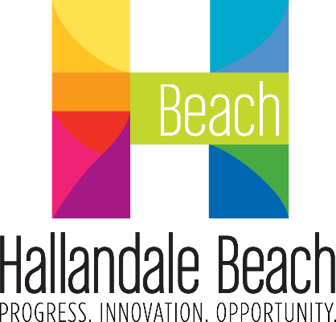
City of Hallandale Beach
City Commission Agenda Cover Memo

Meeting Date: |  | File No.: | Item Type: |  |  |  |  | 1st Reading |  |  | 2nd Reading
1/22/2025 |  | 24-587 | ☒ Resolution  ☐ Ordinance  ☐ Other |  | Ordinance Reading |  |  | N/A |  |  | N/A
 |  | 24-587 |  |  | Public Hearing |  |  | ☐ |  |  | ☐
 |  | 24-587 |  |  | Advertising Required |  |  | ☐ |  |  | ☐
 |  | 24-587 |  |  | Quasi-Judicial: |  |  | ☐ |  |  | ☐
Fiscal Impact ($): |  | Account Balance ($): |  |  | Funding Source: |  |  |  |  | Project Number:
N/A |  | N/A |  |  | N/A |  |  |  |  | N/A
Contract/P.O. Required |  | RFP/RFQ/Bid Number: |  |  | Sponsor Name: |  |  |  |  | Department:
☐ Yes | ☒ No | N/A |  |  | Dr. Jeremy Earle, City Manager |  |  |  |  | City Manager’s Office
Strategic Plan Focus Areas:
☒ Fiscal Stability |  | ☒ Resident Services |  | ☐ Public Safety |  |  | ☒ Infrastructure & Mobility |  | ☐ Economic Development & Affordable Housing
Implementation Timeline:
Estimated Start Date: 3/4/2025 |  |  |  |  |  | Estimated End Date: 9/30/2025

SHORT TITLE:

A RESOLUTION OF THE MAYOR AND CITY COMMISSION OF THE CITY OF HALLANDALE BEACH, FLORIDA, ADOPTING THE “2025 STATE legislative PROGRAM” AS ITS LEGISLATIVE PRIORITIES; authorizing the LEGISLATIVE PROGRAM TO BE PRESENTED TO THE BROWARD COUNTY STATE LEGISLATIVE DELEGATION FOR CONSIDERATION DURING THE 2025 LEGISLATIVE SESSION AND TO GIVE DIRECTION TO BALLARD PARTNERS, INC. AS their PROGRAM; and providing an effective date.

STAFF SUMMARY:

Summary:

Staff seeks City Commission approval and adoption of the proposed City of Hallandale Beach 2025 State Legislative Program.

Background:

Throughout the year, the City Commission discusses various issues for submittal to the Broward County Legislative Delegation and the State Legislators for consideration during the Legislative Session. The 2025 Legislative Session is scheduled to commence on March 4, 2025.

Current Situation:

Ballard Partners, Inc., the City’s lobbying firm, provided guidance on the submittal of direct appropriation requests and made staff available to meet and advise Elected Officials on the upcoming legislative session and related developments.

A draft with recommendations for the City of Hallandale Beach 2025 State Legislative Program is attached. This draft is based on City Commission feedback as well as current issues and input from staff.

Along with the City’s legislative agenda, the following direct appropriation requests are included for consideration during the upcoming session:

- Austin Hepburn Senior Mini Center - $111,006
- Northeast Quadrant Injection Wells System - $2,000,000
- Comprehensive Stormwater Management and Flooding Mitigation Project – Foster Road and Surrounding Areas - $2,000,000
- NW/SW 8th Avenue Roadway Reconstruction Project - $1,815,000

Why Action is Necessary:

Action by the City Commission will result in the adoption of the City’s State Legislative Program. The Legislative Program establishes the City’s legislative goals, gives direction to our lobbying firm, Ballard Partners, Inc., and provides a City Commission authorized list of issues for the members of the Broward Delegation and other legislators during the 2025 Legislative Session.

Cost Benefit:

The City will benefit from the potential receipt of state funding and related savings resulting from the advocacy of State Legislators.

PROPOSED ACTION:

The City Commission considers the attached Resolution.

ATTACHMENT(S):

Exhibit 1 – Resolution
Exhibit 2 – Draft 2025 State Legislative Program

Prepared By: | Noemy Sandoval
Noemy Sandoval
Assistant City Manager

Reviewed By: | Jeremy Earle
Dr. Jeremy Earle
City Manager

