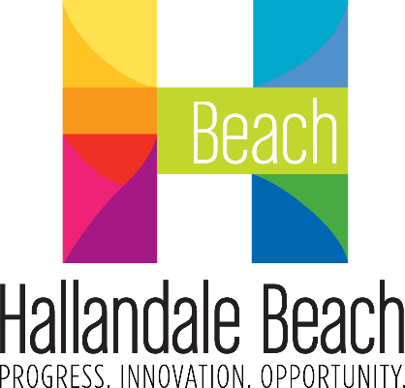
City of Hallandale Beach
City Commission Agenda Cover Memo

Meeting Date: |  | File No.: | Item Type: |  |  |  |  | 1st Reading |  |  | 2nd Reading
1/22/2025 |  | 24-358 | ☐ Resolution  ☒ Ordinance  ☐ Other |  | Ordinance Reading |  |  | 12/18/2024 |  |  | 1/22/2025
 |  | 24-358 |  |  | Public Hearing |  |  | ☒ |  |  | ☒
 |  | 24-358 |  |  | Advertising Required |  |  | ☐ |  |  | ☒
 |  | 24-358 |  |  | Quasi-Judicial: |  |  | ☐ |  |  | ☐
Fiscal Impact ($): |  | Account Balance ($): |  |  | Funding Source: |  |  |  |  | Project Number:
N/A |  | N/A |  |  | N/A |  |  |  |  | N/A
Contract/P.O. Required |  | RFP/RFQ/Bid Number: |  |  | Sponsor Name: |  |  |  |  | Department:
☐ Yes | ☐ No | N/A |  |  | Anabelle Lima-Taub,Commissioner andJoy F. Cooper,Mayor |  |  |  |  | City Commission
Strategic Plan Focus Areas:
☐ Fiscal Stability |  | ☒ Resident Services |  | ☐ Public Safety |  |  | ☐ Infrastructure & Mobility |  | ☐ Economic Development & Affordable Housing
Implementation Timeline:
Estimated Start Date: N/A |  |  |  |  |  | Estimated End Date: N/A

SHORT TITLE:

AN ORDINANCE OF THE MAYOR AND CITY COMMISSION OF THE CITY OF HALLANDALE BEACH, FLORIDA, AMENDING CHAPTER 2 “ADMINISTRATION,” ARTICLE III “BOARDS, COMMITTEES, DISTRICTS AND AUTHORITIES,” SECTION 2-71 OF THE CITY OF HALLANDALE BEACH CODE OF ORDINANCES TO AMEND ADVISORY BOARD AND COMMITTEE QUALIFICATIONS TO REQUIRE BACKGROUND CHECKS; AMENDING SECTION 2-74 TO PROVIDE HOLIDAY SCHEDULING GUIDELINES; PROVIDING FOR CONFLICT; PROVIDING FOR SEVERABILITY; PROVIDING FOR CODIFICATION; AND PROVIDING FOR AN EFFECTIVE DATE.

ATTACHMENT(S):

Exhibit 1 – Proposed Ordinance

