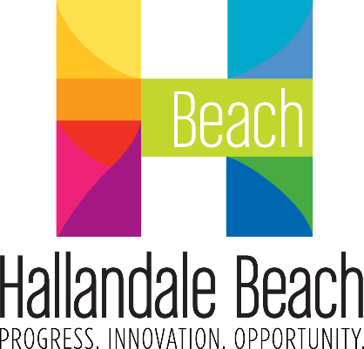
City of Hallandale Beach
City Commission Agenda Cover Memo

Meeting Date: |  | File No.: | Item Type: |  |  |  |  | 1st Reading |  |  | 2nd Reading
1/22/2025 |  | 25-010 | ☒ Resolution  ☐ Ordinance  ☐ Other |  | Ordinance Reading |  |  | N/A |  |  | N/A
 |  | 25-010 |  |  | Public Hearing |  |  | ☐ |  |  | ☐
 |  | 25-010 |  |  | Advertising Required |  |  | ☐ |  |  | ☐
 |  | 25-010 |  |  | Quasi-Judicial: |  |  | ☐ |  |  | ☐
Fiscal Impact ($): |  | Account Balance ($): |  |  | Funding Source: |  |  |  |  | Project Number:
12,500 |  | 531,532.70 |  |  | 1810-545030 Insurance Claims |  |  |  |  | N/A
Contract/P.O. Required |  | RFP/RFQ/Bid Number: |  |  | Sponsor Name: |  |  |  |  | Department:
☐ Yes | ☒ No | N/A |  |  | Jim Buschman, Risk Manager |  |  |  |  | Human Resources/Risk Management
Strategic Plan Focus Areas:
☒ Fiscal Stability |  | ☐ Resident Services |  | ☐ Public Safety |  |  | ☐ Infrastructure & Mobility |  | ☐ Economic Development & Affordable Housing
Implementation Timeline:
Estimated Start Date: 1/22/2025 |  |  |  |  |  | Estimated End Date: 1/24/2025

SHORT TITLE:

A RESOLUTION OF THE MAYOR AND CITY COMMISSION OF THE CITY OF HALLANDALE BEACH, FLORIDA, APPROVING SETTLEMENT OF BODILY INJURY CLAIM WITH FREDERICO BENAVIDEZ; AUTHORIZING SETTLEMENT TO RESOLVE ALL CLAIMS IN EXCHANGE FOR THE EXECUTION OF THE APPROPRIATE RELEASE; AND PROVIDING FOR AN EFFECTIVE DATE.

STAFF SUMMARY:

Summary:

This case involves a City sanitation employee who failed to yield the right-of-way to a vehicle driven by claimant, Frederico Benavidez. As result, both vehicles collided, and the claimant’s vehicle was determined to be a total loss. In July of 2024, the City settled the property damage portion of this claim in the amount of $8,755.78. Mr. Benavidez obtained the services of an attorney to represent him for his bodily injuries (neck, back and knee). The total cost for medical treatment is approximately $33,000. Initially, the claimant’s attorney demanded $200,000 to settle this claim; however, I was able to negotiate a settlement in the amount of $12,500. Considering the severity of the crash and the injuries to the claimant, staff believes settling this case for $12,500 to avoid costly litigation is in the City’s best interest.

Why Action is Necessary:

Pursuant to Section 24-3 (d), the City of Hallandale Beach, Code of Ordinances, proposed
settlements in excess of $20,000 shall be submitted to the City Commission for its decision. This settlement exceeds the authority amount given to the City Manager, and City Attorney to settle claims, which require City Commission approval.

Fiscal Impact:

$12,500

PROPOSED ACTION:

The City Commission considers the attached Resolution.

ATTACHMENT(S):

Exhibit 1 – Proposed Resolution

Prepared By: | Jim Buschman
Jim Buschman
Assistant HR Director/Risk Manager

Reviewed By: | Radu Dodea
Radu Dodea
Human Resources/Risk Management Director

