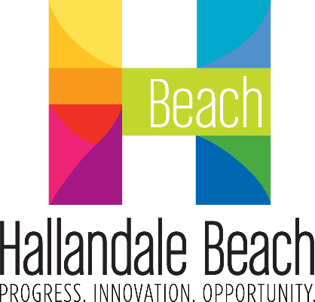
City of Hallandale Beach
City Commission Agenda Cover Memo

Meeting Date: |  | File No.: | Item Type: |  |  |  |  | 1st Reading |  |  | 2nd Reading
1/8/2025 |  | 25-006 | ☒ Resolution  ☐ Ordinance  ☐ Other |  | Ordinance Reading |  |  | N/A |  |  | N/A
 |  | 25-006 |  |  | Public Hearing |  |  | ☐ |  |  | ☐
 |  | 25-006 |  |  | Advertising Required |  |  | ☐ |  |  | ☐
 |  | 25-006 |  |  | Quasi-Judicial: |  |  | ☐ |  |  | ☐
Fiscal Impact ($): |  | Account Balance ($): |  |  | Funding Source: |  |  |  |  | Project Number:
N/A |  | N/A |  |  | N/A |  |  |  |  | N/A
Contract/P.O. Required |  | RFP/RFQ/Bid Number: |  |  | Sponsor Name: |  |  |  |  | Department:
☐ Yes | ☐ No | N/A |  |  | Joy F. Cooper,  Mayor |  |  |  |  | City Commission
Strategic Plan Focus Areas:
☐ Fiscal Stability |  | ☐ Resident Services |  | ☐ Public Safety |  |  | ☐ Infrastructure & Mobility |  | ☐ Economic Development & Affordable Housing
Implementation Timeline:
Estimated Start Date: N/A |  |  |  |  |  | Estimated End Date: N/A

SHORT TITLE:

A Resolution of the MAYOR AND CITY COMMISSION OF THE City of Hallandale Beach, Florida, AUTHORIZING THE RENAMING OF FOSTER PARK TO DR. MARTIN LUTHER KING JR. COMMUNITY PARK; AUTHORIZING THE RENAMING OF FOSTER PARK COMMUNITY CENTER TO DR. MARTIN LUTHER KING JR. DREAM CENTER; AUTHORIZING THE RENAMING OF FOSTER PARK PLAZA TO DR. MARTIN LUTHER KING JR. DREAM PLAZA; WAIVING RENAMING POLICY; and providing for an effective date.

ATTACHMENT(S):

Exhibit 1 – Resolution

